
Dashboard Design

Team ID | MCA
Project Name | Smartphone Usage, Digital Addiction & Well-Being Analytics
Maximum Marks | 5 Marks

Developing an optimized reporting interface relies on intentional asset placement to confirm that the extracted metrics stay clear, highly contextual, and easily scannable for engineering teams. Applying data design rules shifts raw usage datasets into structured diagnostic tools.
Activity 1: Interactive and visually appealing dashboards
Designing a balanced interface involves systematic planning to guarantee that surface graphs stay uncluttered, purpose-driven, and highly informative for researchers. Below are the design principles applied to configure the analytical monitoring console layout:
- Metric Card Aggregations
- Behavioral Feature Clustering
- Chart Selection Standards
- System Color Branding
- Segment Slicers & Filters
- Data Hierarchy Drill-Downs
- Mobile View Responsive Layouts
- Integrated Interface Icon Markers
- Minimal Visual Information Density

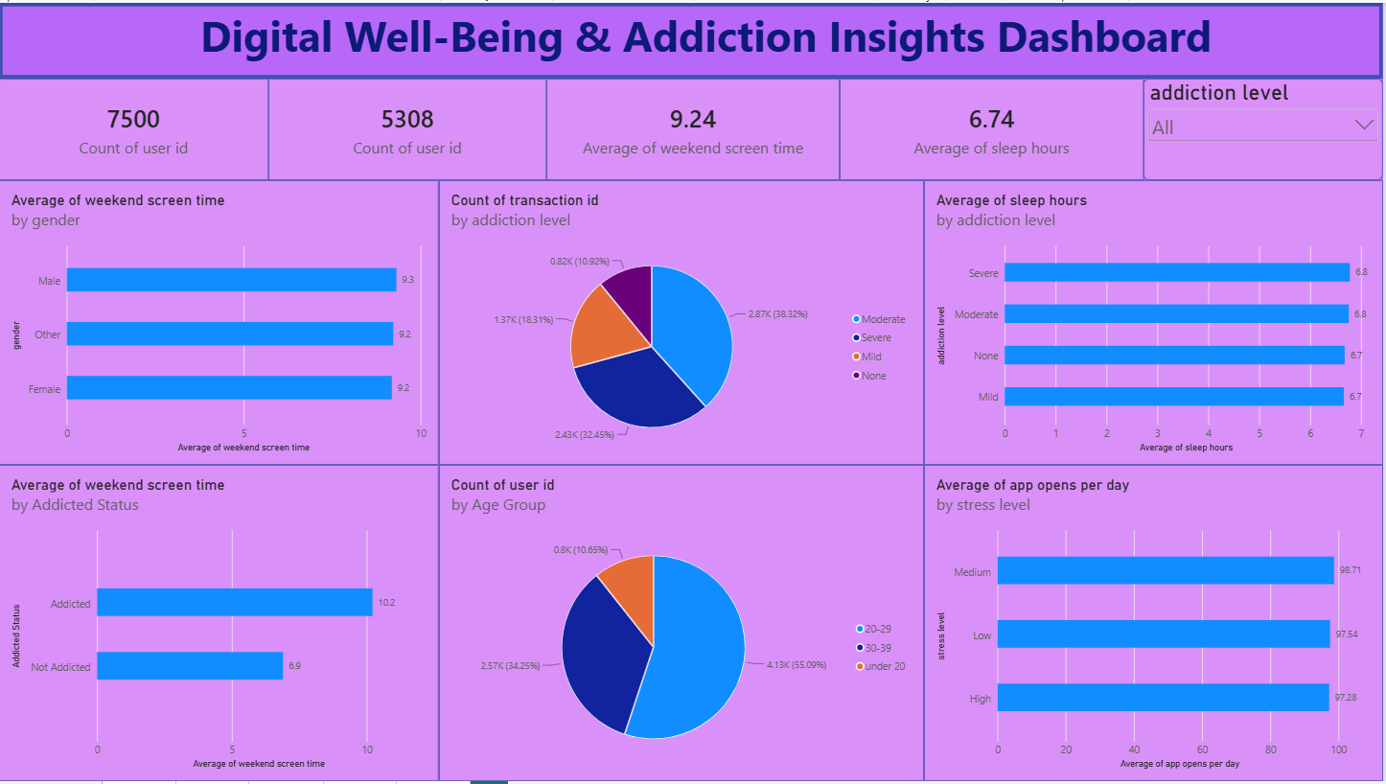

Note: Highlight the major outcomes in form of bullet points
Sample:
Here are five potential outcomes from the dashboard image provided:
- Active Cohort Volume Monitoring: Tracks cumulative interaction footprints across diverse user pools to map long-term behavior benchmarks.
- Feature Imbalance Evaluation: Breaks down active focus shares relative to platform types to pinpoint compulsive app habits.
- Target Vulnerability Tracking: Calculates total high-risk dependency layers across the tracking network to target intervention programs.
- Temporal Shift Modeling: Visualizes standard device usage changes between weekdays and weekend surge blocks.
- Rest Sufficiency Indexing: Maps biological rest constraints alongside app opening triggers to evaluate structural rest fatigue.

